  - Student Writing Challenge Worksheet


Submit your writing challenge for your chance to win!
$100 first prize and $50 second prize awarded in each school category:
Lower school (Years 7–8)
Middle school (Years 9–10)
Upper school (Years 11–12)
And $100 random prize draw for one survey participant.

Local Planning Strategy



Part 1: Watch and Reflect
Watch the video titled "What is a Local Planning Strategy?". After watching, answer the following questions.
1. What is something in your suburb or city that affects you every day?
Hint: Think about your journey to school, local parks, shops, or public transport.
Your response:

2. How do you think decisions are made about housing, parks, sports, or shops?
Hint: Who might make the rules or plans? Who do you think is consulted?
Your response:

3. Why might the City want to hear from students?
Hint: What perspectives do young people offer that adults might overlook?
Your response:

Part 2: Understanding the Local Planning Strategy and using rhetorical devices
As you now know, a Local Planning Strategy (LPS) is a high-level, long-term plan that shapes how the community grows and changes. It affects:
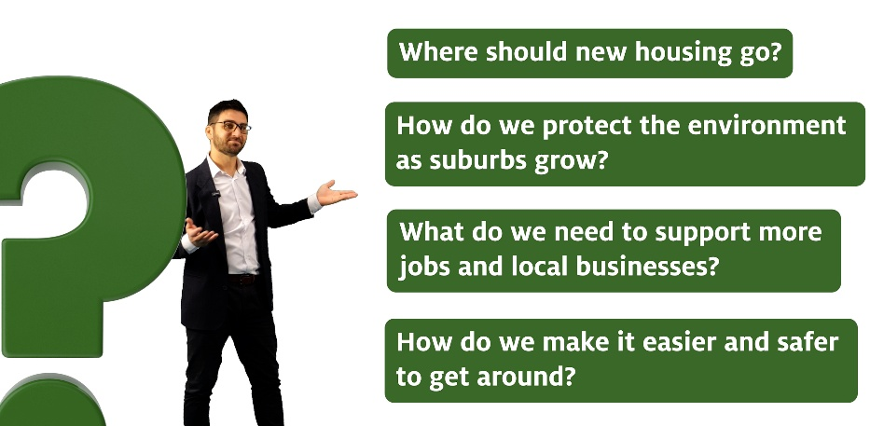
Just like a school timetable gives structure for the year but doesn’t explain the content of every class, the LPS sets direction without deciding every detail. It is important for young people to be part of this conversation because the decisions made now will shape the places where you will live, study, work, and spend your free time. Your ideas can help create a city that works for you now and in the future. You, right now, are making a huge impact on how the City may look!
Have a look at this example:
Councillors, I ask you what kind of City ignores the needs of our most loyal companions? Almost half of all households have a dog but our parks and public spaces don’t reflect that. We need fenced areas where dogs can run freely, safely, and without the risk of injury. Our street can be like a jail without these spaces. They need a place to play, to bark, to belong. Our dogs deserve space. They deserve protection. They deserve better. They deserve more. Let’s make room for them in our Local Planning Strategy. For happiness of our dogs, for our own happiness… after all, the City is our home.

See if you can find the techniques used in the above example and place them in the table below.
Technique | Definition | Example 1 | Example 2 | From the above example
Emotive Language | Words that evoke strong feelings | “Everyone deserves a safe place to call home.” | “Without green space, our suburbs lose their heart.” (this is personification as well)
Rhetorical Question | A question posed to provoke thought, not an answer | “Why should your postcode decide your future?” | “Is this really the kind of city we want to leave behind?”
Inclusive Language | Using ‘we’, ‘our’, ‘us’ to create unity | “We all want better streets and public spaces.” | “Our future depends on the choices we make together.”
Evidence | Facts, data, or concrete examples | “Kalamunda’s population is expected to grow by 20%.” | “95 percent of residents care about local tree canopy in suburbs.”
Call to Action | A statement that urges action or change | “Let’s make housing affordable for future generations.” | “It’s time to plan smarter, for all of us.”
Anaphora | Repetition of a word or phrase at the beginning of successive lines | “We need safer streets. We need greener parks. We need better plans.” | “A city that listens, a city that includes, a city that acts.”
Amplification | Expanding on an idea for emphasis | “It’s not just housing we need. It’s housing that’s affordable, accessible, and sustainable.” | “We’re not just growing. We’re growing in ways that must work for everyone.”
Metaphor | A figure of speech that compares one thing to another | “Planning without a strategy is like sailing without a compass.” | “Our suburbs are the lungs of the city.”
Simile | A comparison using ‘like’ or ‘as’ | “A planning strategy is like a school timetable – it guides the flow but not every detail.” | “Without green space, the city feels like a house without windows.”
Asyndeton | Listing ideas without conjunctions for emphasis | “More homes, more paths, more parks, more places to belong.” | “Safer roads, cleaner air, stronger neighbourhoods.”

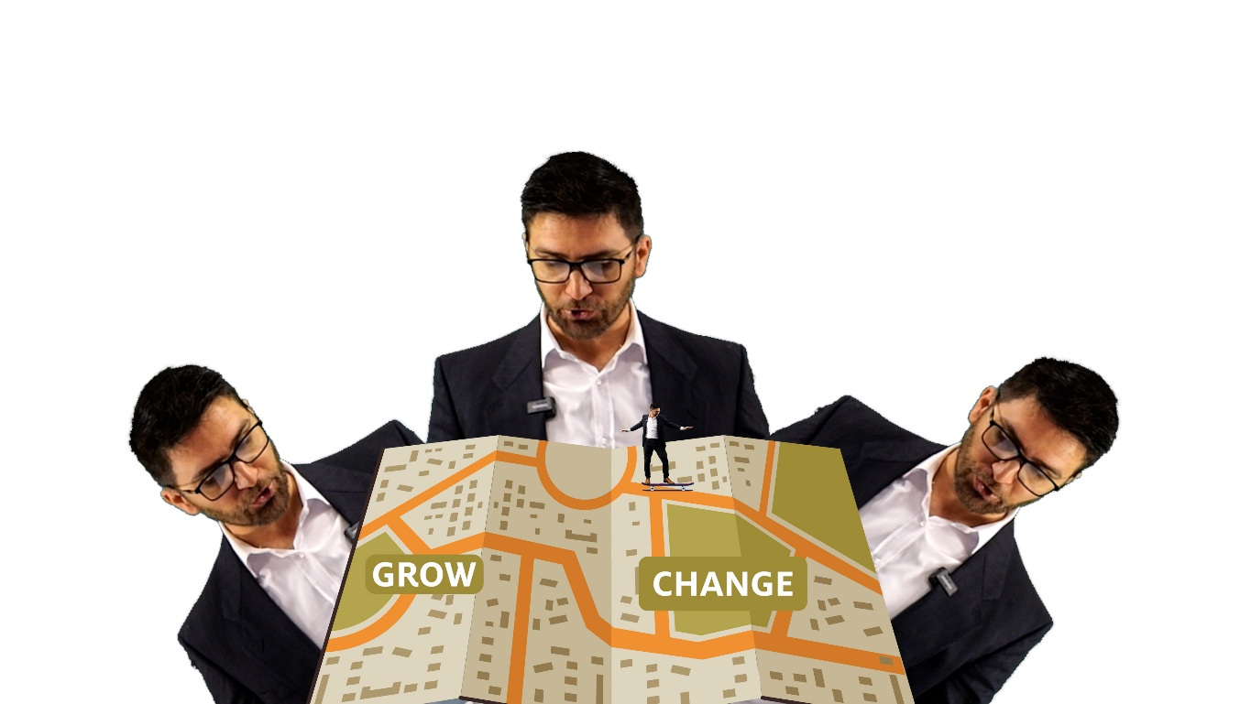

Part 3: Planning Your Persuasive Piece
Write a persuasive response (maximum 300 words) on one change you would like to see in your community and why it matters. Like the dog one above.
Your response can be in the form of:
- A short speech to Council
- A letter to Council
- An opinion piece or editorial to a newspaper to get the Council’s attention

Planning Your Persuasive Text
Think about something you'd like to change, add, or improve in your community. Use the questions and prompts below to shape your persuasive piece.

Step 1: What change do you want to see?
Describe a clear idea. It might relate to housing, transport, nature, recreation, local shops, public safety, or anything you care about.
Prompt:
What’s one change you want to see in your suburb or the City of Kalamunda?

Write here:

Step 2: Why does it matter to you?
Explain why this matters to you personally. Is it something you experience every day? Something that makes life harder, or that brings joy?
Prompt:
Why do you care about this? How would it affect your life or your family?

Write here:

Step 3: Support it with a fact or example
Include a fact, example, or story that supports your point. Think about something you've noticed, read, or experienced.
Prompt:
What’s one fact or example that shows this is important?

Write here:

Step 4: Try to persuade
Now, speak to the reader directly. You might want to appeal to their values (fairness, safety, community), ask a rhetorical question, or paint a picture of the future.
Prompt:
What would you say to convince someone who doesn’t agree with you?

Write here:

Step 5: Use persuasive techniques
Look at the table of persuasive techniques provided in your worksheet. Try to use at least four of the following:
- Emotive language
- Rhetorical question
- Anaphora (repetition of a phrase at the beginning of lines)
- Amplification (expanding on a strong idea)
- Metaphor or simile
- Asyndeton (lists without conjunctions)
Optional tip:
Use a short story or scene to draw the reader in. You could start with “Imagine a city where...” or “Every morning I see...” or “Without this, our suburb would...”.
You can draft your ideas using the scaffold below, then transfer it to a final typed version if submitting online.

Part 4: Writing Your Persuasive Piece

Writing Scaffold (Optional)

Title:

Opening Statement (Introduce the issue and your opinion):

Main Point 1:
Supporting evidence or example:

Main Point 2:
Supporting evidence or example:


Call to Action (What do you want the City to do?):

Click here to submit your persuasive writing piece here:

https://engage.kalamunda.wa.gov.au/local-planning-strategy/student-persuasive-writing-competition


Why not enter the survey for another chance to win (and make an impact)?
  - You can be in the draw to win 1 of 3 gift cards. $100 first prize and $50 second prize awarded in each school category:
- Lower school (Years 7–8)
- Middle school (Years 9–10)
- Upper school (Years 11–12)

Enter here:
engage.kalamunda.wa.gov.au/local-planning-strategy/student-survey

